**D- Printing the Controller Files**

Info:

I am going to start this document assuming that you have already have obtained the files that are located in the Printer Files folder in the base of this GitHub directory. Once you have the files from there, we can continue on and I will explain the proper way to print them.

Once you have the file, you need to obtain a slicing program, I prefer Cura3D, but there are many out there that will work. When you have the software, you will need to make sure to format it for your printer, you will need to add a non-networking printer and locate where your printer is. When you have done that it should show you a virtual bed with nothing on it, the correct dimensions of the printer bed. Here is an example of what it should look like:

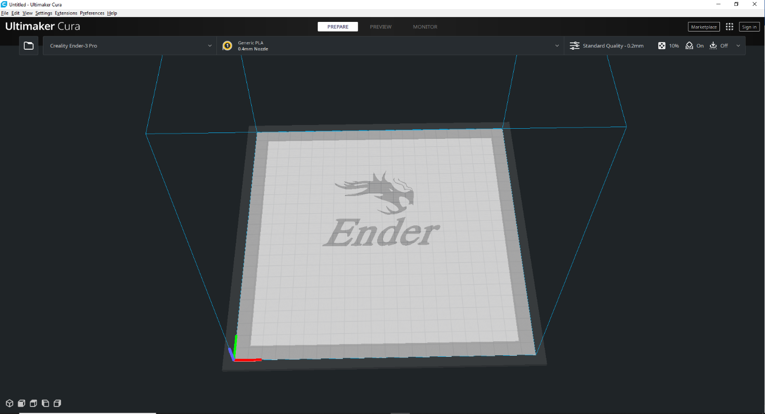

When you have this, you can click on the folder in the top left corner and it will allow you to choose the file and drag it into the file program. On Cura it shows a yellow model if it works, but if it is too big or outside of the bed, it will show as a grey color, examples of this are:

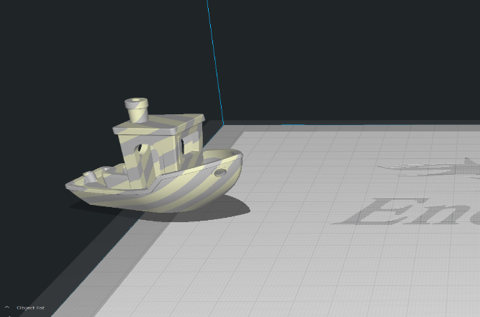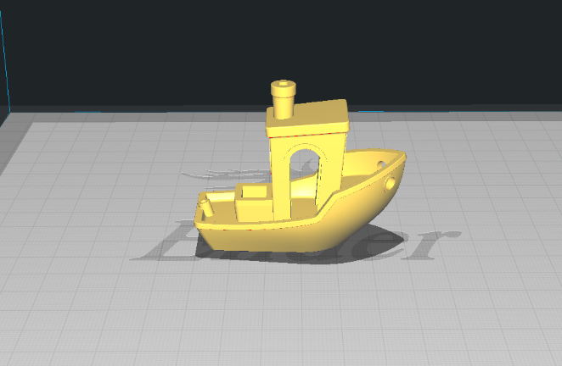

Not Working ^ Working ^

When you have gotten the file into your software (I am just going off of cura again, I do not know other softwares) you should be able to see in the top right corner there is some settings that you can change as to make the print better, such as infill and supports. For this file you will not need to change anything, seeing as the default 20% infill is more than enough, and this does not need any supports or adhesion help.

Once you have it all centered how you want, you can click on slice in the bottom right, save it to your sd card that you have connected, and bring it to the printer. That is all you need to do for basic printing, if you need more help, google can go more in depth because people know a lot more than I do.